### **Pogrebnak Illua**

1) Viewing files and folders through the file manager in the terminal:

○ Command: ranger (make sure you have installed the ranger package: sudo apt-get install ranger).

View web pages through a browser running in the terminal:

○ Command: lynx or links (install them with sudo apt-get install lynx or sudo apt-get install links).

View email in the terminal:

○ Command: mutt (install it with sudo apt-get install mutt).

Listen to music through the terminal:

○ Command: cmus (install with sudo apt-get install cmus).

Download torrents through the terminal:

○ Use transmission-cli or rTorrent. For example, for Transmission: sudo apt-get install transmission-cli.

Plan activities in the calendar and remind about them through the terminal:

○ Use calcurse. Install it with sudo apt-get install calcurse.

View the image in the terminal:

○ Command: imgcat or feh (install it with sudo apt-get install feh).

1) Entering, editing and deleting text (file editors):

● nano: A light text editor with a simple interface. Install it with sudo apt-get install nano.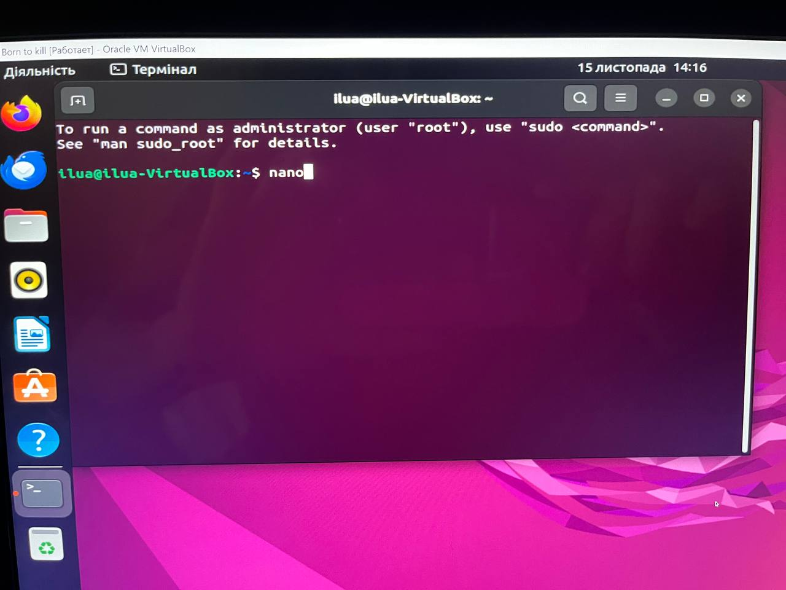

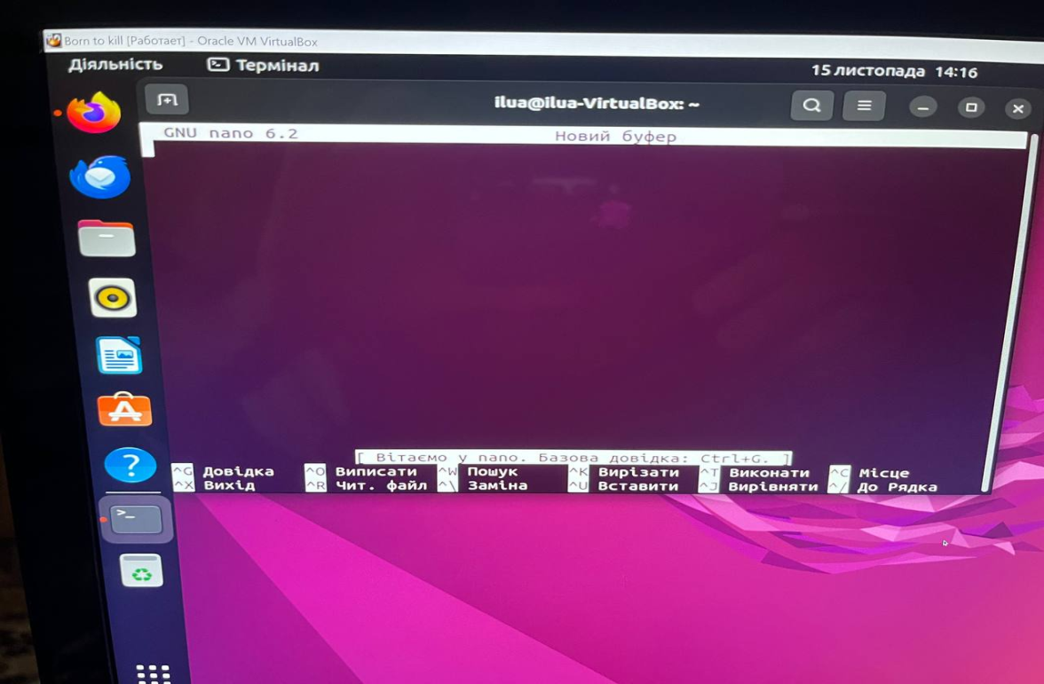

● vim or vi: A powerful text editor with input and command modes. Install it with sudo apt-get install vim.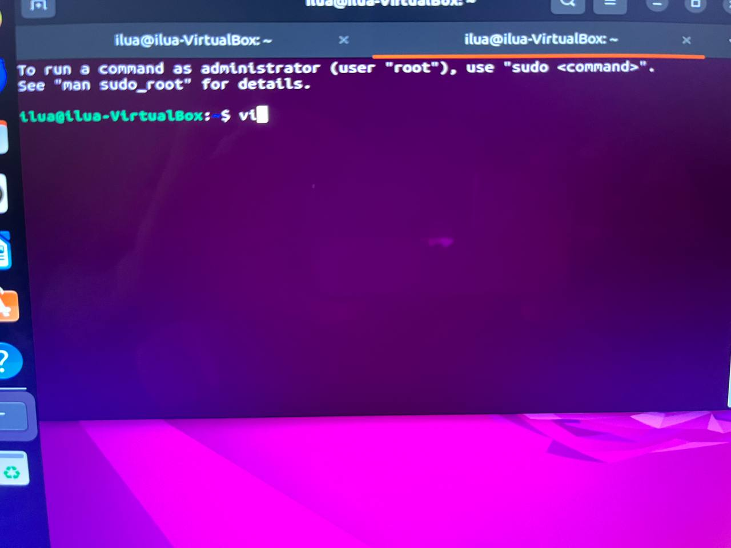

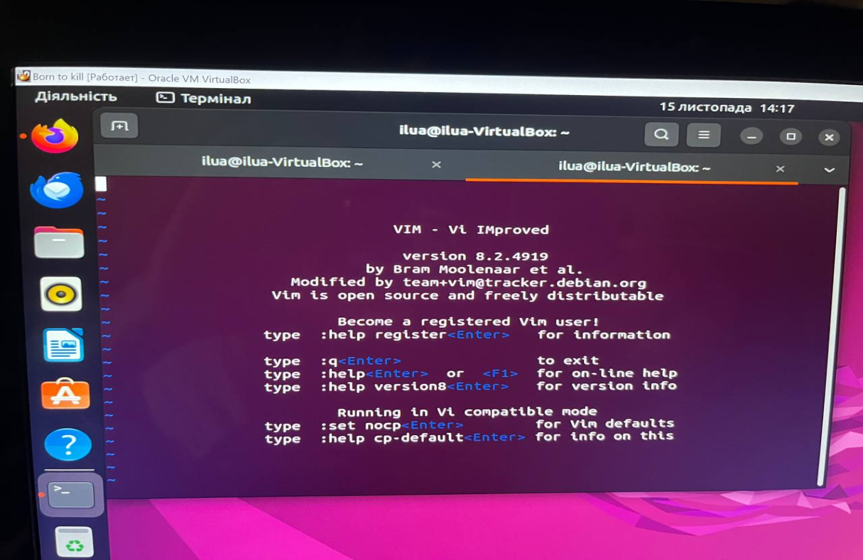

* + Monitoring of processes and system resources:**htop**:

● An interactive system monitor that shows lists of processes and resources. Install it using sudo apt-get install htop.

● top: A command that displays system information and a list of active processes. Installation: sudo apt-get install procps.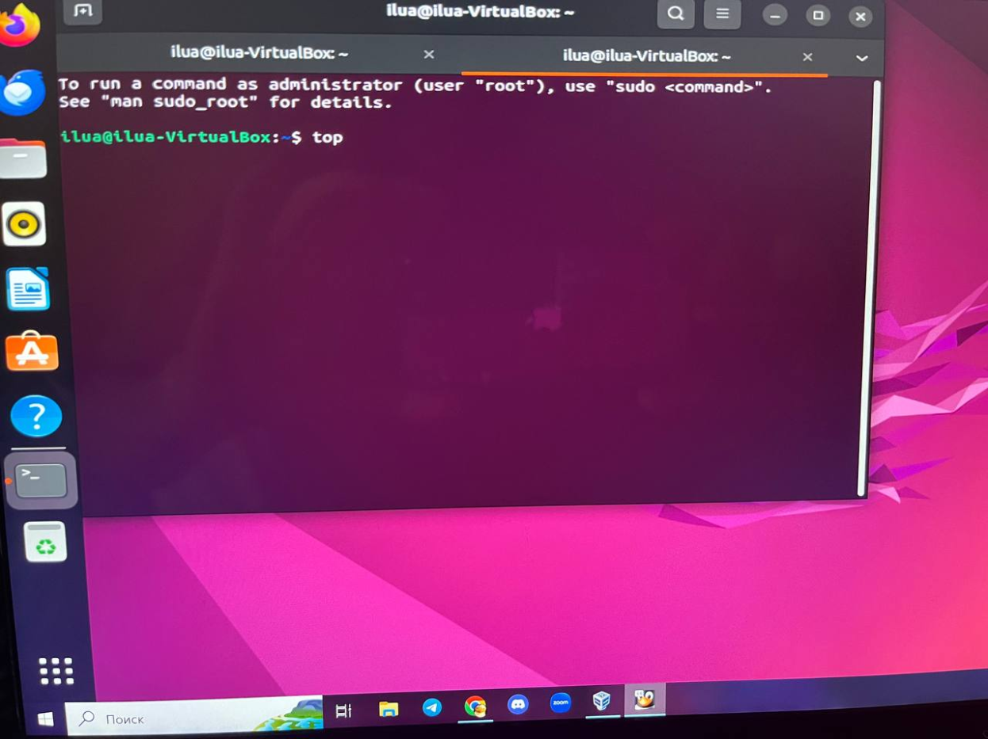

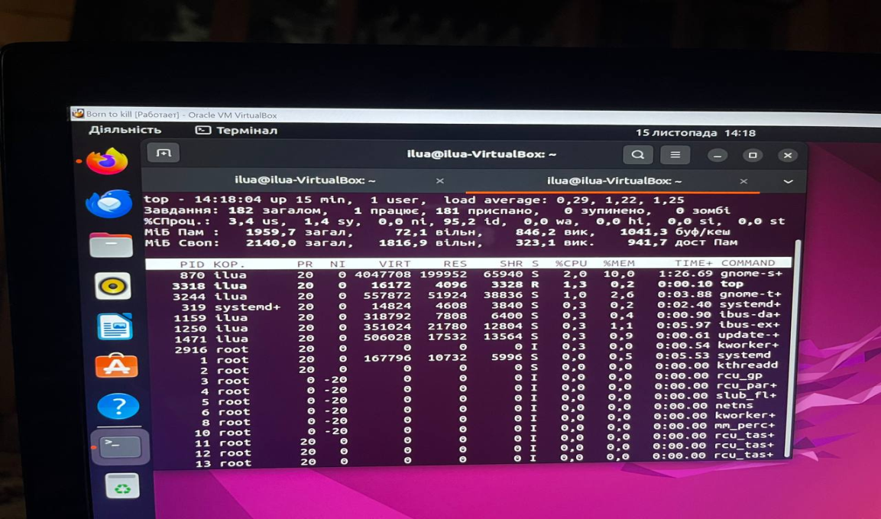

● iotop: I/O monitoring at the system level. Installation: sudo apt-get install iotop.

**Tseluiko Stanislav**

3. Tasks to lift the mood in the middle of the work process ☺ - the so-called "Easter eggs":

Star Wars teams in the terminal:

Install the telnet utility and use the following command in the terminal:

telnet towel.blinkenlights.nl

This will play Star Wars in a terminal window.

Fortune and Cowsay:

Install fortune and cowsay and add the following alias to your

.bashrc or .zshrc file:

alias fortune='fortune | cowsay'

Now, every time you open a new terminal and type fortune, you'll get a random aphorism or funny text in the form of a picture.

"sl" mode:

Install the sl (Steam Locomotive) program and type in the terminal:

sl

Instead of the normal ls output, you'll see an animated train running through your terminal.

"nyan" mode:

If installed, run the command:

nyan

You will see an animated cat spaceship "Nyan Cat".

The "sl" command with an improvement:

Install the sl program and create an alias:

**alias sl='sl -e'**

Now, when you type sl, the train will not only go through, but also "fly" into the air.

**Translated by Barabash Matviy**